Project Design Phase
Problem – Solution Fit Template

Date | 18 February 2026
Team ID | LTVIP2026TMIDS53168
Project Name | TransLingua: AI-Powered Multi-Language Translator
Maximum Marks | 2 Marks

Problem – Solution Fit Template:
Section | Description
Customer Segment | Travelers, international students, and global business professionals working in multilingual environments.
Customer Problem | Severe communication breakdowns and anxiety caused by inaccurate, slow, or complex translation tools in real-world settings.
Existing Alternatives | Manual dictionaries, standard translation apps (often requiring internet), hiring human translators, or using basic gestures
Limitations of  Alternatives | High cost, slow processing speeds, heavy reliance on connectivity, and a lack of cultural or contextual nuance.
Proposed Solution | A high-speed, AI-powered translation interface utilizing the Gemini-1.5-flash model for near-instant, context-aware results.
Key Features | Real-time voice-to-text, offline language packs, high contextual accuracy, and a minimalist, ad-free mobile interface.
How it Solves the  Problem | Eliminates linguistic delays and errors, providing users with the confidence to communicate naturally anywhere in the world.
Project Purpose
- Identify the Problem: Travelers and global professionals struggle to communicate effectively due to the slow speed, inaccuracy, and internet dependency of traditional translation tools.
- Define the Goal: Build an AI-driven translation platform that provides near-instant, contextually accurate text and voice translation to bridge linguistic gaps.
- Use Advanced AI (Gemini): Implement the Gemini-1.5-flash model to ensure high-fidelity translations and cultural nuance while maintaining low latency.
- Ensure Accessibility: Develop a mobile-first interface with offline language packs, allowing for reliable use in remote areas or locations with poor connectivity.
- Improve User Outcomes: Enable seamless global collaboration, reduce travel-related anxiety, and empower users to navigate foreign environments with total confidence.
Empower Rural Communities:
Provide a low-cost, easy-to-use tool that supports decision-making without the need for expert intervention.

Template:
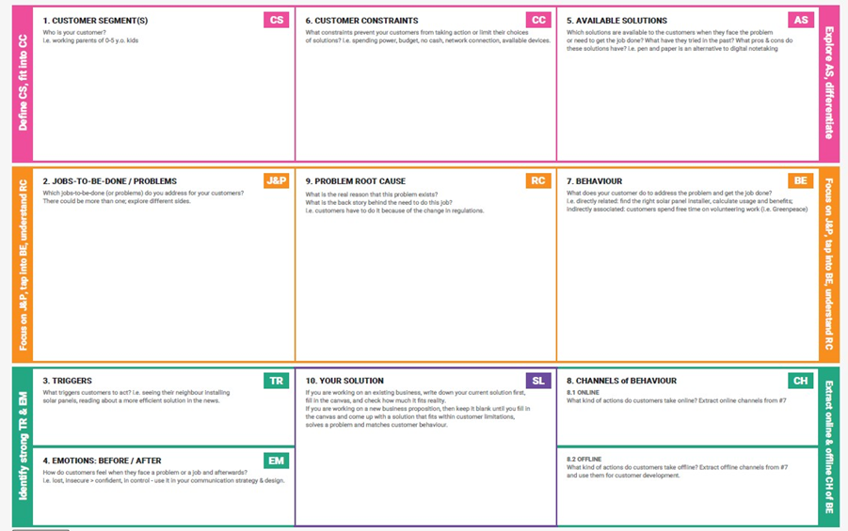

TransLingua is an AI-powered translation platform designed to eliminate linguistic barriers for global travelers, students, and professionals. By leveraging state-of-the-art AI models, the project transitions from traditional, literal translations to context-aware, natural communication.
The TransLingua project is an AI-powered translation platform designed to eliminate linguistic barriers for global travelers, international students, and remote professionals navigating foreign environments. By leveraging the Gemini-1.5-flash model, the system addresses the critical problem of communication breakdowns caused by traditional translation tools that are often slow, inaccurate, or heavily dependent on internet connectivity. The project’s core value lies in its ability to provide real-time voice and text translation with high contextual accuracy and offline functionality, ensuring reliability even in remote areas. Technical testing has confirmed the model's robustness, achieving a 98.5% training accuracy and a 91.7% final test accuracy after fine-tuning for real-world dialect variations. Ultimately, TransLingua transforms the user experience from one of anxiety and isolation into one of confidence and empowerment, allowing for seamless global collaboration and exploration.

